Hi friends, we appear to be having some disconnects with the who, how, and when of TE. The following document provides you directions for CONTINUING STUDENT applications pages 1 and 2. Pages 3 and 4 are suggestions and directions for FIRST TIME NEW IMPORT APPROVAL.
CONTINUING STUDENT INFORMATION
- All ELIGIBLE CONTINUING EXPORT should now be recertified.
- Applications tab click the + to unpack your options
- Enrollment Report – click to open – scroll to the EXPORTS and confirm that every eligible student is RECERTIFIED. If the student still says RECERTIFY click on the student’s name and follow the prompts.
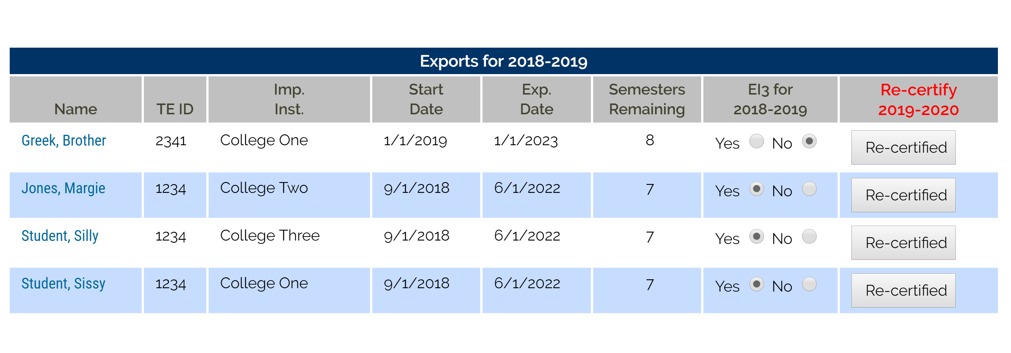
- All ELIGIBLE CONTINUING IMPORTS should appear in your VIEW SUBMISSIONS
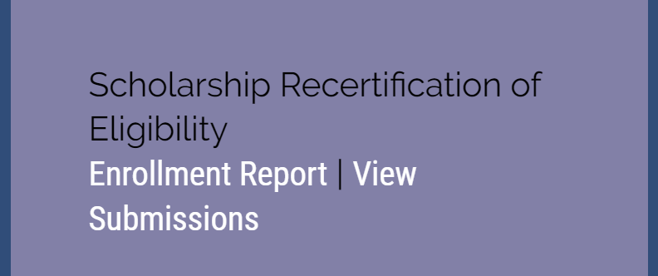
- Click to open View Submissions.
- Imports – New Continuing Forms are all your continuing students who have been RECERTIFIED by their EXPORT school
- Imports – New Continuing Forms are all your continuing students the EXPORT school has recertified.
- Once the spring term is over, and grades are available, please be sure you “fund” each eligible student in advance of June 15.
- You need to enter the scholarship amount – no $, no commas, or decimal points and whole numbers only.
- Years – enter 4 for all undergrads and 2 for all graduate students.
- You can add any generic comments or leave blank.
- Click SUBMIT to approve
- This record moves from Imports - New Continuing Forms to Imports – Approved Continuing Forms.

In the case that a student is NO LONGER eligible for the TE scholarship at your school due to academics, issues of social deportment, or just not returning, you need to update the student’s record.
CONTINUING STUDENT INFORMATION CONTINUED
- Click to open View Submissions
- Imports – New Continuing Forms
- Once you learn the student is not returning, update the record by
- Entering 0 (zero) in the scholarship amount
- Years – still 4 or 2
- Approved is NO
- Comments – if you like
- Click Submit
- This record moves from Imports- New Continuing Forms to Imports – Rejected Continuing Forms.
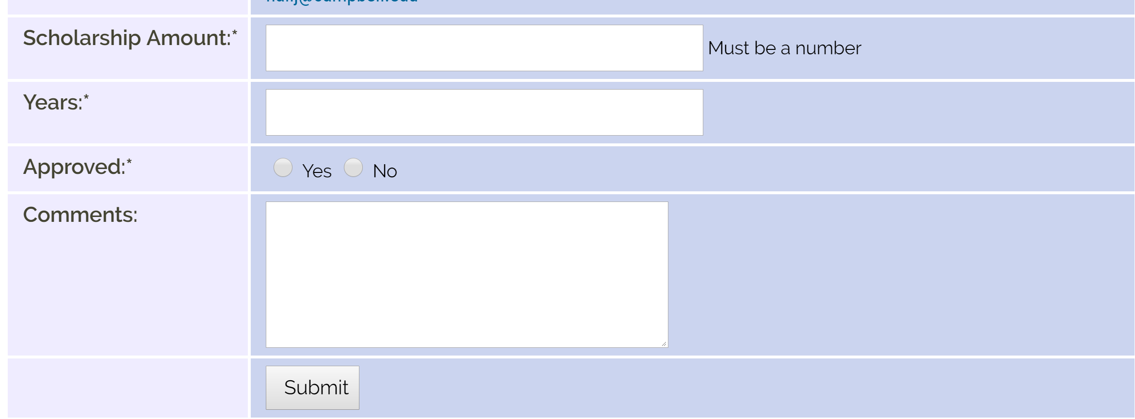
- Continuing students can track the process of their continuing TE scholarship application.
- www.tuitionexchange.org – select the Families tab, and the following will appear
- 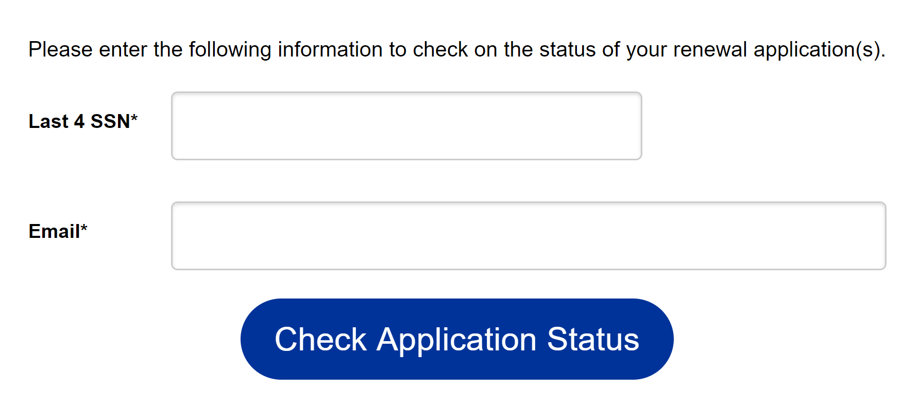 The TEID and email must match the original information entered into the system.
- The student will see only information for the school she enrolled. NEW means the EXPORT school has RECERTIFIED the application for the next academic year.
- This student’s application for the next academic year has been recertified by the Export school, AND the IMPORT school has funded the student for the next academic year.
- If the student transfers mid-year, it is possible the student may find two applications. It occurred when the EXPORT school recertified the student and then the student transferred. In this situation, it is important to review the name of the IMPORT school.
NEW STUDENT INFORMATION
All eligible NEW STUDENT IMPORTS are officially anxious, at least their moms are anxious. Please consider reviewing your IMPORT Applications (new) very soon
- Applications tab click the + to unpack your options
- Import Applications (new) click to open – select Decision Pending 2019-2020 and click to open
- If you have not already done so, you need to share this information with your Admissions Office. These students should be admitted before you provide them with the offer of a TE Scholarship.
- If the student is admitted, now is the time to make your TE scholarship decisions.
- Click on the student’s name to open the record, scroll down to the DECISION section and fill in the blanks.
Approved means you are offering the student a TE scholarship; Denied means you are not providing the student a TE scholarship. Please do not get hung-up on the verbiage. Waitlisted means you are still considering the student for a TE scholarship.
- IMPORT schools do not have the option to withdraw.
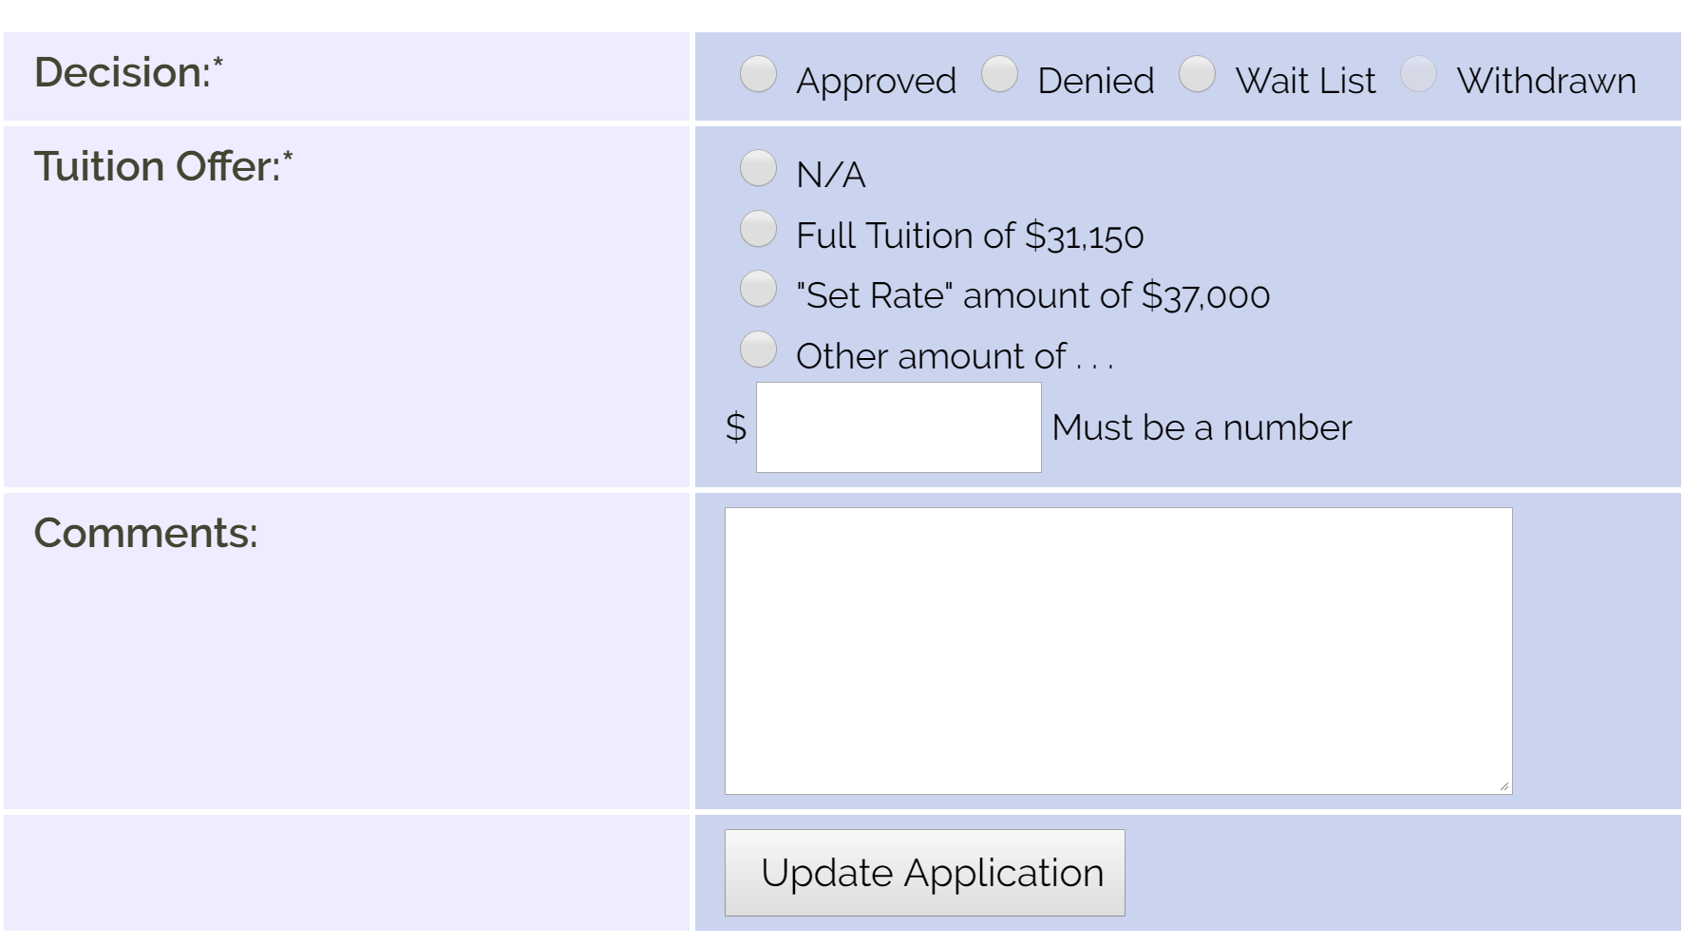

- The next item that requires completion is the Tuition Offer. As a reminder, all TE schools are obligated to provide full tuition or Set-Rate which ever is less. Schools can provide TE scholarship dollars in excess of Set-Rate. The tuition offer may include federal and state grants for those students who qualify. These dollars may be used to offset the full or Set-Rate cost of tuition. In the case of providing less TE scholarship dollars because of such off-sets, be sure your consumer information is very clear and shared in advance of or with the scholarship offer.
- You need to click the appropriate radio button. The amount of tuition or set-rate should automagically fill in the white box. If it does not, or the number is no correct, please enter the whole number only in the white box. Leave out dollar signs, commas, and periods. Other amount would reflect the actual scholarship award when other dollars are subtracted, or in the case where the school is offering more than the Set-Rate but not full tuition.

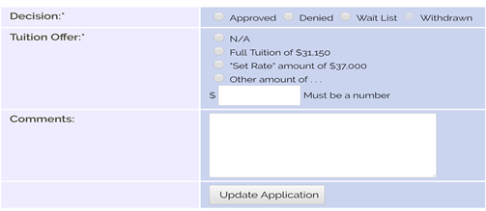

NEW STUDENT INFORMATION CONTINUED
The final item that requires completion is the Comment section. This might include a message about state and federal dollars or a general welcome message. It can also be left empty.
- Now that each section has something recorded, the comment section may be left empty, and it is time to CLICK UPDATE Application.
- Now your student, parent, and EXPORT TELO are notified that your school approved this application. These emails come from norreply@tuitionexchange.org. This mailbox is not monitored. If an invalid email address is provided on the application by the family, the email goes to a dead email box. TE Central is not able to generate a new notification email.
- DO NOT check the ENROLLED BOX until Fall, 2019 when the student is actually enrolled at your school.
- Some terminology to consider if your school is not yet ready to make TE scholarship offers. If the student has completed the application process and is admitted, move the student to the category of WAITLIST.
- If the student has not done anything except complete the TE application, I suggest considering moving the student to denied. Add a comment that indicates the student DID NOT make or complete her APPLICATION for admission.
- New students and their parent can track the process of their TE scholarship applications. In order to do so, the information entered MUST match the information entered on the TE scholarship application EXACTLY!
- TE Central will not update any application when requested by the family. The Export TELO can update any information on an application that is found in the white boxes.

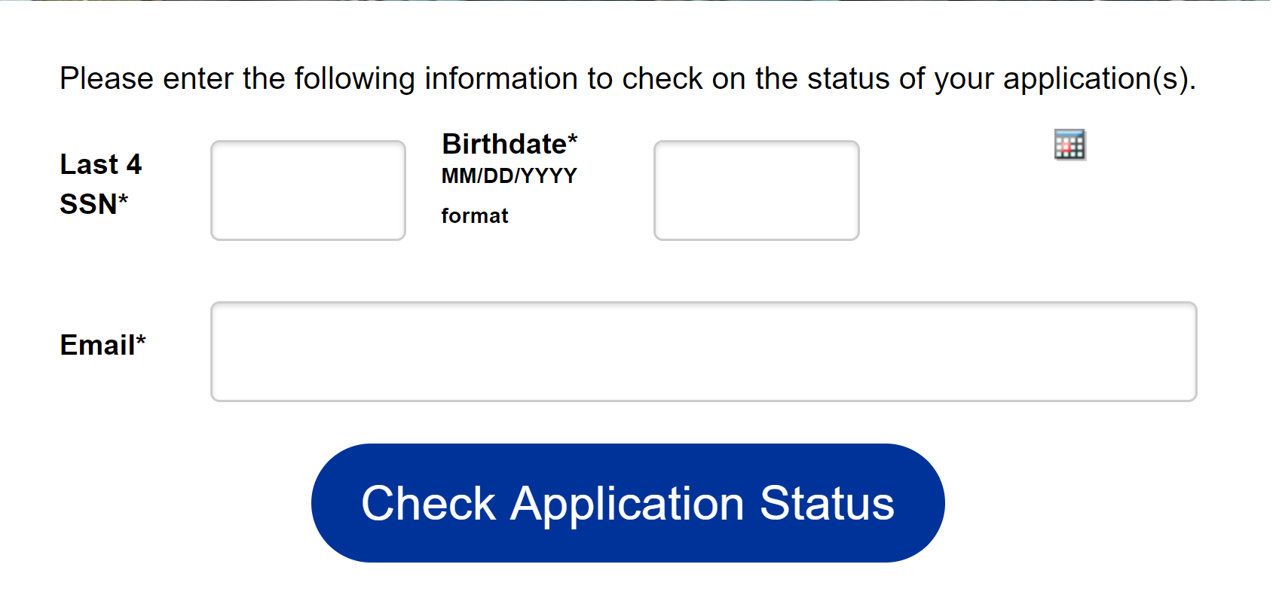
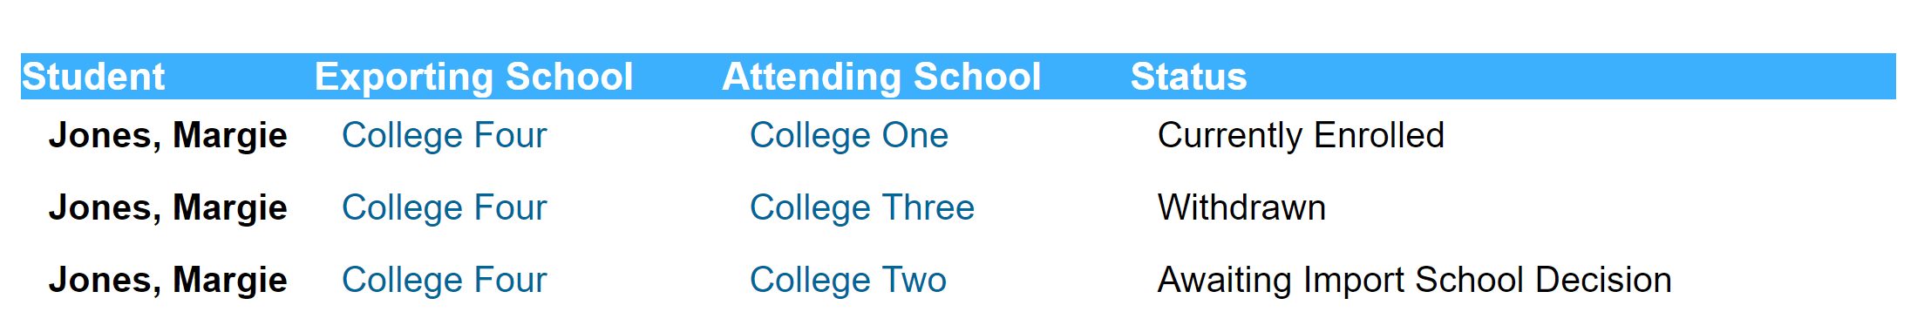

If you have questions, I did not address; please email me directly. Thanks for reading. The first 10 people who email with the secret word found in the header will receive a treat. Good luck and thank you for all that you do for students and their families seeking assistance in funding higher education.

Janet Dodson
Jdodson@tuitionexchange.org
402.418.1081 central time

