March 2019
TO: Financial Aid Colleagues at Tuition Exchange Institutions
FROM: Robert D. Shorb, Executive Director/CEO
Janet Dodson, Associate Director of Communications
RE: Tuition Exchange Scholarship Import Verification report
Your school is a member of Tuition Exchange (TE), and the Tuition Exchange Liaison Officer is responsible for completing the Enrollment Report annually in September. The Enrollment Report is organic and lists all enrolled students attending your school and receiving a Tuition Exchange scholarship during the 2018-19 academic year. To confirm your school’s Enrollment Report is accurate, TE Central is asking every Financial Aid Office (FAO) to review the report ensuring that your school is reporting all TE scholars funded during the 2018-19 academic year. To confirm that you 2018-19 Enrollment Report is accurate, we ask that you log into the Tuition Exchange system and verify all information on the Enrollment Report is accurate. The following pictures walk you visually through the process.
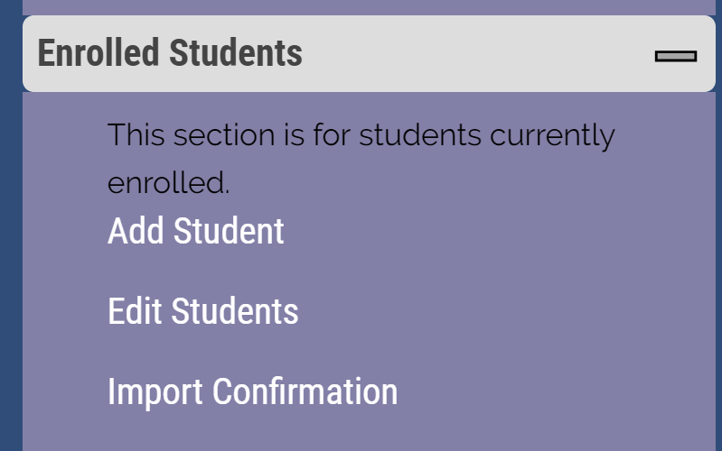Select Import Confirmation
The Financial Aid office confirms or denies each student. Confirm means enrolled and funded with a TE Scholarship during some part of the 2018-19 academic year. Deny means the student has NEVER received a TE Scholarship at any time during the 2018-19 academic year. Each financial aid office will receive a 30 day login code for this project. This code will be separate from the TE Central assignement code. The code email will be sent to the TE Laison Officer and the Financial Aid Director indentified on the Institutional Overview.
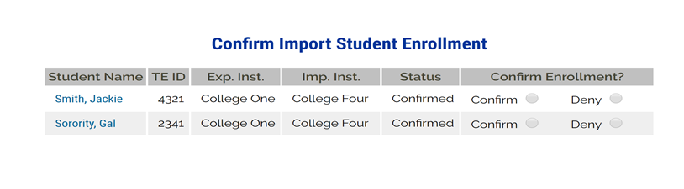
It is crucial that the FAO confirm with institutional records that all students receiving institutional TE scholarships during the 2018-19 academic year appear on the Enrollment Report. The Financial Aid Office only needs to review and confirm 2018-19 IMPORTS. Import TE scholarships provide your school with the ability to increase TE exports. When your institution's Enrollment Report fails to include funded Imports accurately, fewer of your employees may be able to access Tuition Exchange scholarships.
The imports detailed on the report require review, confirmation or updating and report submission no later than April 19, 2019. Should you discover individual student corrections are needed, or a student(s) is missing from the Enrollment Report please work directly with your TE Liaison Officer to add, update, or delete any TE student scholars? It is the responsibility of the TE Liaison Officer to make the changes to the Enrollment Report prior to April 19, 2019. If you don’t know who your school’s TE Liaison Officer is, the name and email address are available on the Enrollment Report.
TE Central appreciates your assistance with this Import Verification review. Please add this task to your calendar for upcoming years, as this is an annual confirmation activity. If you have questions regarding the Enrollment Report, please contact your TE Liaison Officer.

