General Program Questions

Q. When we approve an import, is that the same as an offer?
A. Yes, the words approve and offer are interchangeable.

Q. Any reason to use double credit if we participate in EI3?
A. If your school needs to be exporting more than three students each year and you are not attracting enough imports; DC 3 allows you the opportunity to buy imports. This will help you to export more students. Remember imports give you power to export.

Q. If the institution has a long record of Good Standing is there benefit to participating in E/I3 or DC 3?
A. For institutions that have sufficient numbers of imports, E/I 3 and/or DC 3 is not necessary. These programs were developed to assist TE schools who experienced more export requests than their import credits are able to support.

Q. So when DO we have to worry about the import/export balance?
A. Schools are expected to maintain a healthy import/export balance. Below is the formula to calculate your standing.
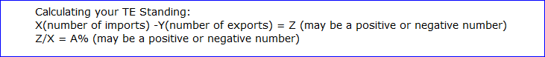
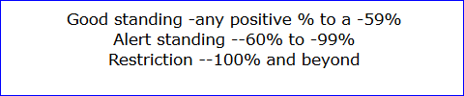

Q. If a school has exported more than 3 students (not all have been accepted at this point...) should schools set a process to only allow 3 applications for exports (with a wait list in case they aren't accepted)?
A. This is a tricky question with several potential answers.
1. How many imports are you expecting to enroll? If an equal number to the exports – no worries.
2. Do you have any banked import credits from past years? If yes, no worries.
3. Check out your Balance Sheet and calculate your TE standing. Be sure to use the 5 Year Subtotal as your calculating figures.
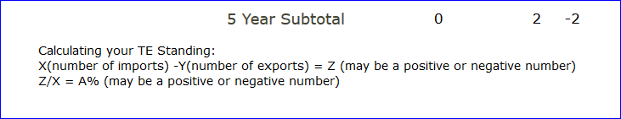

Q. Why are email addresses necessary for DC3? Are any auto-emails sent to them? What if we don't have a parent email address?
A. While email addresses are not necessary for DC 3 students and auto-emails will not be sent to DC 3 students. TE Central is requesting that TELO’s add email addresses for all traditional TE students. Overall TELO’s have been vocal in wanting TE Central to provide automated emails to families regarding initial applications entered and recertification confirmation.
Q. TE is available for 8 semesters (right?), can students who take a summer semester be eligible for TE?
A. TE Central encourages all schools to provide TE funding to undergraduate students for eight (8) semesters or graduation whichever is first; however, you are in control of your institutional guidelines. The issue with summer is unique. The TE system counts each period of enrollment as one semester. If a student is provided assistance in the summer and you provide a maximum of eight semesters of funding, the student may end up short. Typically, summer is less expensive and might be the term to fund from personal resources rather than using TE funding. I suggest you visit with others on campus – especially in the Financial Aid Office about this as a funding option.

Q. When entering the eligible semesters, is that for 2014-15 and forward?
A. Not sure I understand this question, but when entering eligible semesters you count beginning
With the first semester of enrollment until graduation or eight (8) semesters if that is the school’s institutional policy.

Q. Please explain the withdrawal button on the export applications.
A. The withdrawal button is to be used for the student who does not return mid-year. This action updates the student’s expiration date.

General website questions

Q. Where is the Institutional Profile found on the TELO website?
A. www.tuitionexchange.org Sign into your TELO portal using your TE credentials
Select Mandatory Institutional Profile section
Click on the first option – Mandatory Institutional Profile
Scroll to question 7 and change the answer to YES and click to submit.
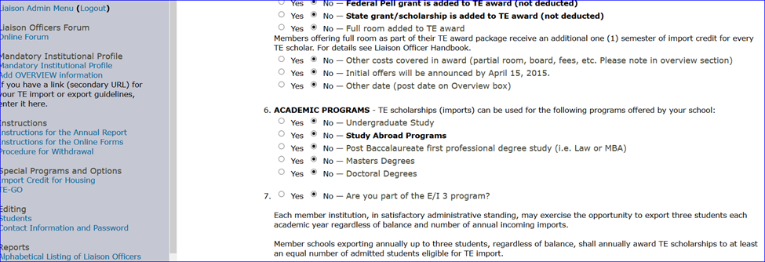

Q. Where is the TELO Only Resources section of our website?
A. www.tuitionexchange.org select the Member Resources tab (last one on the right) Then click on TELO Only Resources. The screen below is presented. Email address is TELO@tuitionexchange.org and the Password is TELO14. All must be typed exactly as presented.

Export/Import 3 (E/I 3) questions

Q. What happens if you have no applicants to offer scholarships, can you still export 3 under E/I 3?
A. Schools signed up for the E/I 3 program can export a maximum of three NEW students annually. Remember, the E/I 3 program basically provides three free exports before the Balance Sheet is affected negatively.

Q. If five (5) students are exported and three are designated E/I 3; do we have to worry about balance?
A. Balance is the issue when schools export more than 3 without importing students to cover the excess beyond three.

Q. If I understand correctly, if we accept at least 3 applicants who meet admissions criteria, we can export unlimited without concern of falling out of balance
A. Not exactly. E/I 3 provides for three exports without the need to import TE students to your school. If you export beyond three in any given year without imports to balance the exports beyond three – TE Central will be calling you.

Q. For 2014/15 E/I 3 designations, do they have to be first year exports in 2014/15? Is there any written criteria for selecting who serves as an E/I 3 student?
A. Schools can designate any student as an E/I 3 student. TE Central encourages schools to designate first year students so that schools are able to maximize the E/I 3 credits available. The TE Handbook explains the program – you are encouraged to review that resource. It is available in the TELO ONLY Resource section of the website filed in the Communications folder.

Q. What happens in the case of an E/I 3 student transferring to another TE school?
A. When an E/I 3 student transfers the only change is the school.
Q. My schools recently joined E/I 3. Am I able to get back in to label E/I students now?
A. Absolutely. On July 1 the 2014-2015 Annual Report will be frozen.

Q. Please explain difference between DC3 and E/I 3 again.
A. E/I 3 provides schools who sign-up three (3) free exports annually before the Balance Sheet is affected. DC 3 is open to any school who offers exchange programs through the list of TE recognized exchange programs. If your school needs to increase imports – DC 3 offers a solution.

